“***Creating of Culture of Excellence***”

# Laboratory Assignment - 1

## **Course Title :** System Analysis & Design Laboratory

## **Course Code :** CSE- 326

## **Assignment Name :** Generalization and Association.

## Submitted By:

### ID : 171442552

### Name : Md. Harun Or Rashid

### Program : CSE(Eve)

### Batch : 44th

### Date : 29-06-2019

## Submitted To:

### Supta Richard Philip

### Senior Lecturer, Department of CSE

### City University, Bangladesh

Contents

Laboratory Assignment - 1 1

**Course Title**  **:** System Analysis & Design Laboratory 1

**Course Code**  **:** CSE- 326 1

**Assignment Name :** Generalization and Association. 1

Submitted By: 1

ID : 171442552 1

Name : Md. Harun Or Rashid 1

Program : CSE(Eve) 1

Batch : 44th 1

Date : 29-06-2019 1

Submitted To: 1

Supta Richard Philip 1

Senior Lecturer, Department of CSE 1

City University, Bangladesh 1

Generalization 3

Generalization 4

Association 4

Association 5

THE END 5

### Generalization

In UML modeling, a generalization relationship is a relationship in which one model element (the child) is based on another model element (the parent). Generalization relationships are used in class, component, deployment, and use-case diagrams to indicate that the child receives all of the attributes, operations, and relationships that are defined in the parent.

To comply with UML semantics, the model elements in a generalization relationship must be the same type. For example, a generalization relationship can be used between actors or between use cases; however, it cannot be used between an actor and a use case.

You can add generalization relationships to capture attributes, operations, and relationships in a parent model element and then reuse them in one or more child model elements. Because the child model elements in generalizations inherit the attributes, operations, and relationships of the parent, you must only define for the child the attributes, operations, or relationships that are distinct from the parent.

The parent model element can have one or more children, and any child model element can have one or more parents. It is more common to have a single parent model element and multiple child model elements.

# Generalization

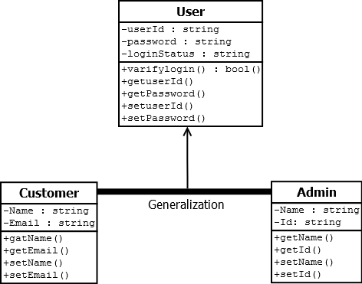

### Association

An association indicates that the system you are developing stores links of some kind between the instances of the associated types. Generally, it does not imply anything about the implementation of the links. For example, they might be pointers, rows in a table, cross-referenced names in XML, and so on.

An association is a diagrammatic method of showing an attribute or pair of attributes. For example, if you have defined a class Restaurant to have an attribute of type Menu, you can state the same definition by drawing an association between Restaurant and Menu.

To draw an association, click **Association** in the toolbox, click the first type, then the second. You can click the same type two times to show that instances can be linked with other instances of the same type.

# Association

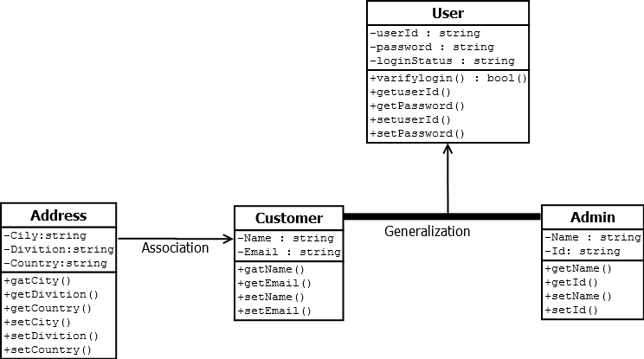

# THE END